ECA0901 – DIGITAL SIGNAL PROCESSING

C01 – AT3 SIMULATION EXPERIMENT – 3
Design of IIR Filters Using Impulse Invariance and Bilinear Transformation Methods Using MATLAB

OUTPUT:
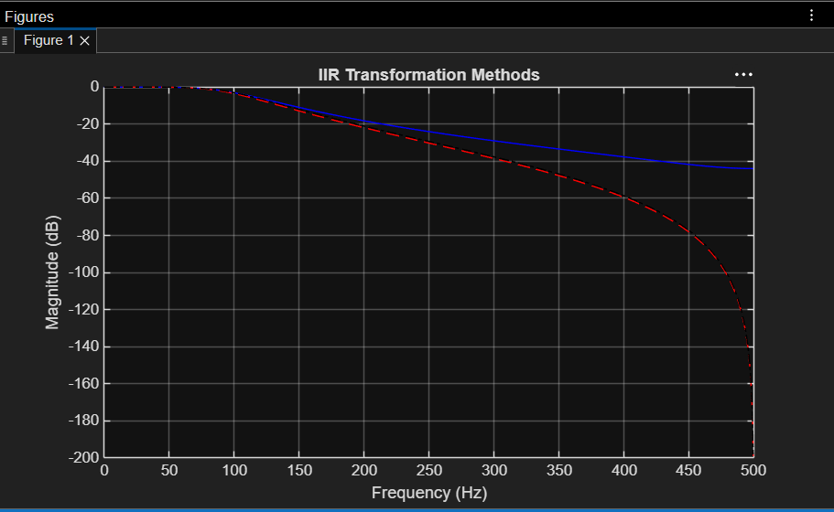

OUTPUT PARAMETERS:
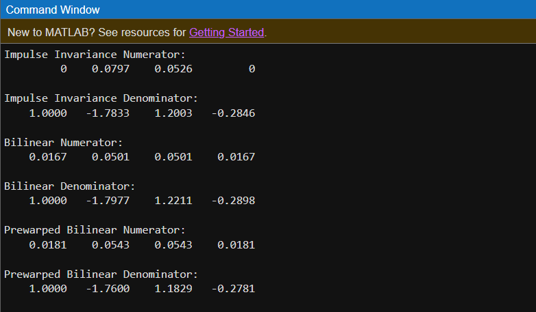

RESULT:
To Design of IIR Filters Using Impulse Invariance and Bilinear Transformation Methods satisfied outcomes using MATLAB

